


3
4
10 20 10 25
5
7 7 7 7 7
2
100 1

7
5
3
5
5
8 6 4 8 9
3
8 5 2
4
101 120 110 215
5
1711 171 711 71 71
2
110 11

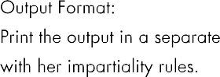
13
6
10
11
3

int s[MAXN]; void sol() read(s[i])

Code:
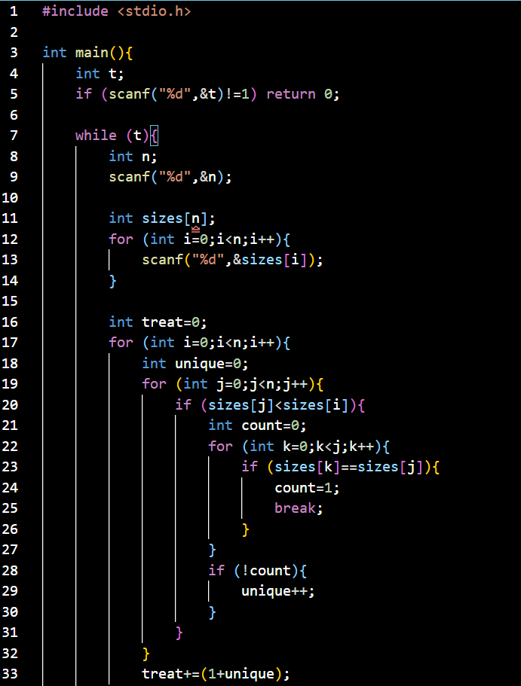

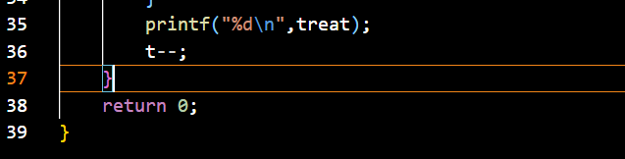

Output:


13 325 51

